Bank Loan Portfolio Analysis Using

SQL Server
  - Data-Driven KPI and Dashboard Reporting through SQL Query Optimization
Prepared by: Ashutosh Pant
Role: Data Analyst | SQL Developer |
BI Enthusiast
Email: ashutoshpant.855@gmail.com
GitHub: https://github.com/ORE0000
LinkedIn: https://www.linkedin.com/in/ashutosh-pant1/

Contents
1. Executive Summary 3
2. Business Problem & Objectives 3
3. Data Overview 3
4. Dashboard 1: KPI Summary 4
Total Loan Applications 4
Total Funded Amount 4
Total Amount Received 5
Average Interest Rate 5
Average Debt-to-Income Ratio (DTI) 6
Good Loan KPIs 7
Bad Loan KPIs 8
5. Dashboard 2: Visualization Insights 10
Monthly Trends by Issue Date 10
Regional Analysis by State 11
Loan Term Analysis 12
Employee Length Analysis 12
Loan Purpose Breakdown 13
Home Ownership Analysis 14
6. Dashboard 3: Loan Status & Quality Analysis 15
7. Observations & Recommendations 15
8. Case Study Discussion 15
9. Appendix: SQL Reference 16

1. Executive Summary
This project provides a comprehensive analysis of the bank's loan portfolio using SQL Server. It focuses on extracting key loan metrics, creating performance dashboards, and evaluating loan quality. Through a combination of SQL-based KPIs and visual insights, this report supports data-driven decision-making and helps identify trends in lending, funding, and repayment behaviors.

2. Business Problem & Objectives
The goal of this project is to assess and monitor the bank’s lending activities by developing a SQL-based reporting system that tracks loan KPIs such as Total Applications, Funded Amount, and Repayment Behavior.
Key Objectives:
• Develop reusable SQL scripts for KPI tracking.
• Create time-based metrics (MTD, PMTD, MoM).
• Classify loans into 'Good' and 'Bad' categories to evaluate portfolio quality.

3. Data Overview
The dataset `bank_loan_data` contains information on individual loan applications, including issue dates, loan amounts, payment histories, and borrower financial indicators. It forms the foundation for KPI and trend analyses across dashboards.
Key Columns:
• id – Unique loan identifier
• issue_date – Date of loan issuance
• loan_amount – Total amount funded
• total_payment – Amount received from borrower
• int_rate – Interest rate (%)
• dti – Debt-to-Income ratio
• loan_status – Loan repayment status

4. Dashboard 1: KPI Summary
Source: BankLoanReport_Summary.sql

Total Loan Applications
/*---------------------------------------------------------
Query 2: Calculate Total Loan Applications
Objective:
Compute the total number of loan applications recorded
in the system by counting the unique loan IDs. This KPI
provides a high-level view of the overall loan application
volume over the entire dataset.
---------------------------------------------------------*/
SELECT
COUNT(id) AS [Total Loan Application]
FROM bank_loan_data;

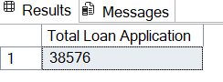
💡 Insight: Shows the total number of loan applications processed during the analysis period.

Total Funded Amount
/*---------------------------------------------------------
Query 7: Calculate Total Funded Amount
Objective:
Compute the total sum of funds disbursed as loans across
the entire dataset. This KPI provides an overview of the
bank's lending volume in monetary terms.
---------------------------------------------------------*/
SELECT
SUM(loan_amount) AS [Total Funded Amount]
FROM bank_loan_data;

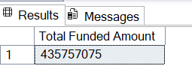
💡 Insight: Represents the total sum of loan funds disbursed to borrowers.

Total Amount Received
/*---------------------------------------------------------
Query 12: Calculate Total Amount Received
Objective:
Compute the total sum of payments received from borrowers
across all loans. This KPI provides an overview of cash
inflows from the bank's lending operations.
---------------------------------------------------------*/
SELECT
SUM(total_payment) AS [Total Amount Received]
FROM bank_loan_data;

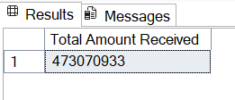
💡 Insight: Tracks total repayments made by borrowers across all loans.

Average Interest Rate
/*---------------------------------------------------------
Query 17: Calculate Average Interest Rate
Objective:
Compute the average interest rate across all loans in the
dataset. This KPI provides insights into the overall cost
of the bank's lending portfolio and helps assess pricing
strategies.

Note:
The interest rate is multiplied by 100 and rounded to two
decimal places for readability and reporting consistency.
---------------------------------------------------------*/
SELECT
ROUND((AVG(int_rate) * 100),2) AS [Average Interest Rate]
FROM bank_loan_data;

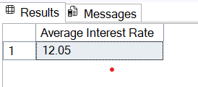
💡 Insight: Indicates the average cost of borrowing across the loan portfolio.

Average Debt-to-Income Ratio (DTI)
/*---------------------------------------------------------
Query 22: Calculate Average Debt-to-Income Ratio (DTI)
Objective:
Compute the average Debt-to-Income (DTI) ratio across all
borrowers. This KPI provides insights into borrowers'
financial health and the overall risk profile of the bank's
lending portfolio.

Note:
The DTI is multiplied by 100 and rounded to two decimal
places for reporting consistency.
---------------------------------------------------------*/
SELECT
ROUND((AVG(dti) * 100),2) AS [Average Debt-to-Income Ratio (DTI)]
FROM bank_loan_data;

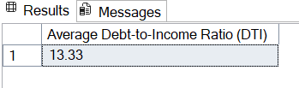
💡 Insight: Helps evaluate borrowers’ financial health and repayment capacity.

Good Loan KPIs
/*---------------------------------------------------------
Query 28: Calculate Good Loan Application Percentage
Objective:
Compute the percentage of loan applications classified as
'Good Loans'. Good Loans are defined as loans with a status
of 'Fully Paid' or 'Current'. This KPI evaluates the quality
of the loan portfolio.
---------------------------------------------------------*/
SELECT
(COUNT(CASE
WHEN loan_status = 'Fully Paid' OR loan_status = 'Current' THEN id
END) * 100)
/
COUNT(id) AS [Good Loan Application %]
FROM bank_loan_data;

/*---------------------------------------------------------
Query 29: Calculate Total Good Loan Applications
Objective:
Count the total number of loan applications that fall under
the 'Good Loan' category (status = 'Fully Paid' or 'Current').
This KPI helps quantify the volume of high-quality loans.
---------------------------------------------------------*/
SELECT
COUNT(*) AS [Total Good Loan Applications]
FROM bank_loan_data
WHERE loan_status = 'Fully Paid' OR loan_status = 'Current';

/*---------------------------------------------------------
Query 30: Calculate Good Loan Funded Amount
Objective:
Compute the total loan amount funded for 'Good Loans'
(status = 'Fully Paid' or 'Current'). This KPI provides
insights into the disbursed amount that is performing well
within the bank's portfolio.
---------------------------------------------------------*/
SELECT
SUM(loan_amount) AS [Good Loan Funded Amount]
FROM bank_loan_data
WHERE loan_status = 'Fully Paid' OR loan_status = 'Current';

/*---------------------------------------------------------
Query 31: Calculate Good Loan Total Received Amount
Objective:
Compute the total payments received from 'Good Loans'
(status = 'Fully Paid' or 'Current'). This KPI reflects the
cash inflow from high-quality loans and indicates the
repayment performance of the good loan segment.
---------------------------------------------------------*/
SELECT
SUM(total_payment) AS [Good Loan Total Received Amount]
FROM bank_loan_data
WHERE loan_status = 'Fully Paid' OR loan_status = 'Current';

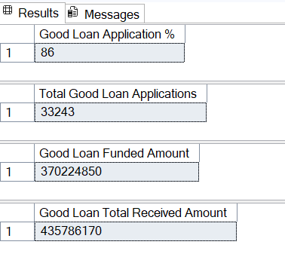
💡 Insight: Measures metrics related to fully paid or current loans, indicating good portfolio performance.

Bad Loan KPIs
/*---------------------------------------------------------
Query 32: Calculate Bad Loan Application Percentage
Objective:
Compute the percentage of loan applications classified as
'Bad Loans'. Bad Loans are defined as loans with a status of
'Charged Off'. This KPI evaluates the risk and quality of the
loan portfolio.
---------------------------------------------------------*/
SELECT
(COUNT(CASE
WHEN loan_status = 'Charged Off' THEN id
END) * 100)
/
COUNT(id) AS [Bad Loan Application %]
FROM bank_loan_data;

/*---------------------------------------------------------
Query 33: Calculate Total Bad Loan Applications
Objective:
Count the total number of loan applications that fall under
the 'Bad Loan' category (status = 'Charged Off'). This KPI
quantifies the volume of high-risk or non-performing loans.
---------------------------------------------------------*/
SELECT
COUNT(*) AS [Total Bad Loan Applications]
FROM bank_loan_data
WHERE loan_status = 'Charged Off';

/*---------------------------------------------------------
Query 34: Calculate Bad Loan Funded Amount
Objective:
Compute the total loan amount funded for 'Bad Loans'
(status = 'Charged Off'). This KPI provides insights into
the disbursed amount that has become non-performing or at
risk, helping assess portfolio risk exposure.
---------------------------------------------------------*/
SELECT
SUM(loan_amount) AS [Bad Loan Funded Amount]
FROM bank_loan_data
WHERE loan_status = 'Charged Off';

/*---------------------------------------------------------
Query 35: Calculate Bad Loan Total Received Amount
Objective:
Compute the total payments received from 'Bad Loans'
(status = 'Charged Off'). This KPI reflects the cash inflow
collected from loans that are at risk or have been charged
off, providing insight into recovery performance.
---------------------------------------------------------*/
SELECT
SUM(total_payment) AS [Bad Loan Total Received Amount]
FROM bank_loan_data
WHERE loan_status = 'Charged Off';

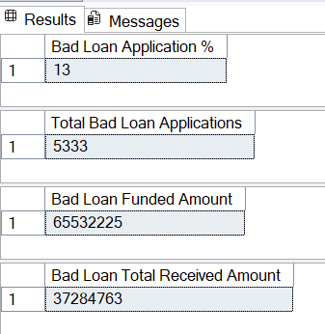
💡 Insight: Captures metrics related to charged-off loans to assess portfolio risk exposure.

5. Dashboard 2: Visualization Insights
Source: BankLoanReport_Overview.sql

Monthly Trends by Issue Date
/*---------------------------------------------------------
Query 1: Monthly Trends by Issue Date
Objective:
Aggregate Total Funded Amount and Total Amount Received
by month (based on 'issue_date') to visualize monthly lending
trends. Ordered chronologically by month.
Metrics:
1. Total Funded Amount
2. Total Amount Received
---------------------------------------------------------*/
SELECT
DATENAME(MONTH, issue_date) AS [MONTH],
SUM(loan_amount) AS Total_Funded_Amount,
SUM(total_payment) AS Total_Amount_Received
FROM bank_loan_data
GROUP BY
DATENAME(MONTH, issue_date),
DATEPART(MONTH, issue_date)
ORDER BY
DATEPART(MONTH, issue_date);

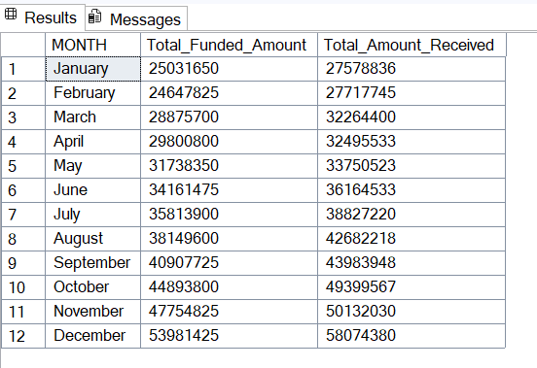
💡 Insight: Shows temporal patterns in loan applications, funding, and repayments.

Regional Analysis by State
/*---------------------------------------------------------
Query 2: Regional Analysis by State
Objective:
Summarize lending metrics by state to support geographic
insights. Useful for filled map visualization.
Metrics:
1. Total Loan Applications
2. Total Funded Amount
3. Total Amount Received
---------------------------------------------------------*/
SELECT
address_state,
COUNT(id) AS Total_Loan_Applications,
SUM(loan_amount) AS Total_Funded_Amount,
SUM(total_payment) AS Total_Amount_Received
FROM bank_loan_data
GROUP BY address_state
ORDER BY address_state;

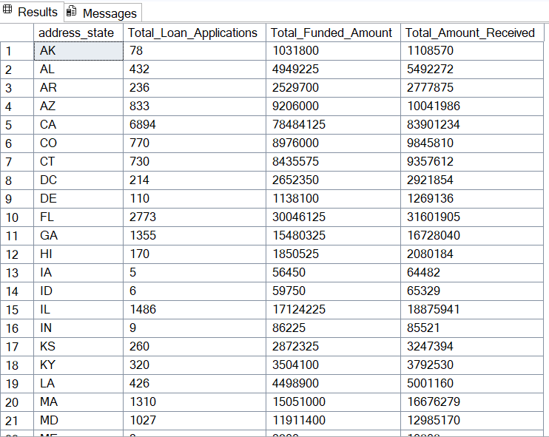
💡 Insight: Highlights geographical differences in lending performance and distribution.

Loan Term Analysis
/*---------------------------------------------------------
Query 3: Loan Term Analysis
Objective:
Aggregate lending metrics by loan term (e.g., 36 months,
60 months) to understand distribution and performance.
Metrics:
1. Total Loan Applications
2. Total Funded Amount
3. Total Amount Received
---------------------------------------------------------*/
SELECT
term AS Loan_Term,
COUNT(id) AS Total_Loan_Applications,
SUM(loan_amount) AS Total_Funded_Amount,
SUM(total_payment) AS Total_Amount_Received
FROM bank_loan_data
GROUP BY term;

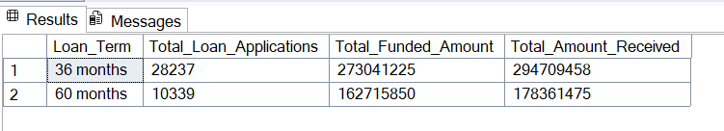
💡 Insight: Displays how loan terms (e.g., 36 vs 60 months) influence lending patterns.

Employee Length Analysis
/*---------------------------------------------------------
Query 4: Employee Length Analysis
Objective:
Summarize lending metrics based on borrower employment
length. Useful for analyzing risk or lending patterns
across employment durations.
Metrics:
1. Total Loan Applications
2. Total Funded Amount
3. Total Amount Received
---------------------------------------------------------*/
SELECT
emp_length AS Employee_Length,
COUNT(id) AS Total_Loan_Applications,
SUM(loan_amount) AS Total_Funded_Amount,
SUM(total_payment) AS Total_Amount_Received
FROM bank_loan_data
GROUP BY emp_length
ORDER BY COUNT(id) DESC;

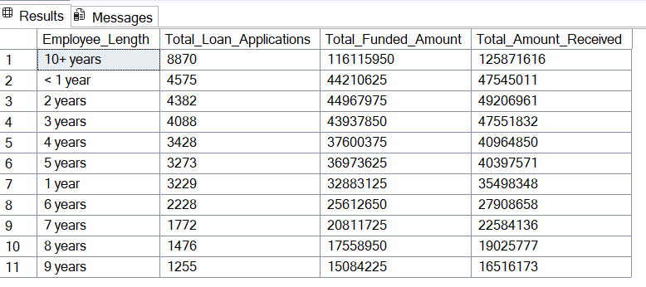
💡 Insight: Examines the relationship between borrower employment length and loan outcomes.

Loan Purpose Breakdown
/*---------------------------------------------------------
Query 5: Loan Purpose Breakdown
Objective:
Aggregate lending metrics by loan purpose (e.g., debt
consolidation, credit card refinancing). Supports bar
chart visualization.
Metrics:
1. Total Loan Applications
2. Total Funded Amount
3. Total Amount Received
---------------------------------------------------------*/
SELECT
purpose,
COUNT(id) AS Total_Loan_Applications,
SUM(loan_amount) AS Total_Funded_Amount,
SUM(total_payment) AS Total_Amount_Received
FROM bank_loan_data
GROUP BY purpose
ORDER BY COUNT(id) DESC;

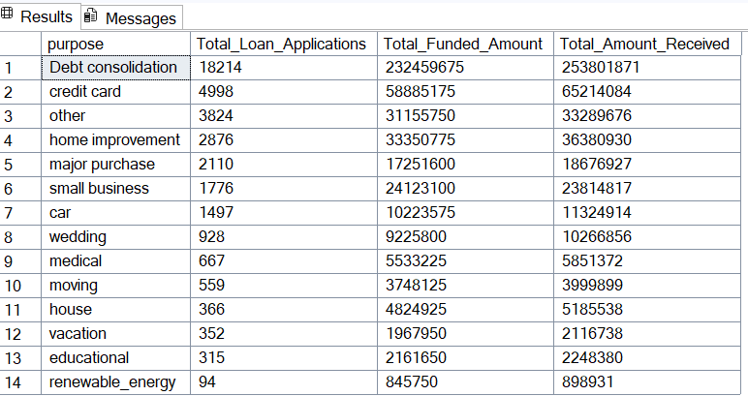
💡 Insight: Categorizes loans by purpose to identify the most common financing reasons.

Home Ownership Analysis
/*---------------------------------------------------------
Query 6: Home Ownership Analysis
Objective:
Aggregate lending metrics by home ownership category
(e.g., own, rent, mortgage) for hierarchical treemap
visualizations.
Metrics:
1. Total Loan Applications
2. Total Funded Amount
3. Total Amount Received
---------------------------------------------------------*/
SELECT
home_ownership,
COUNT(id) AS Total_Loan_Applications,
SUM(loan_amount) AS Total_Funded_Amount,
SUM(total_payment) AS Total_Amount_Received
FROM bank_loan_data
GROUP BY home_ownership
ORDER BY COUNT(id) DESC;
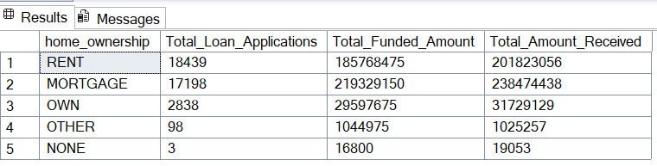
💡 Insight: Shows lending metrics segmented by borrowers’ home ownership status.

6. Dashboard 3: Loan Status & Quality Analysis
This section evaluates loan quality by distinguishing between Good and Bad Loans based on repayment status. It provides a performance overview and helps identify risk concentrations.
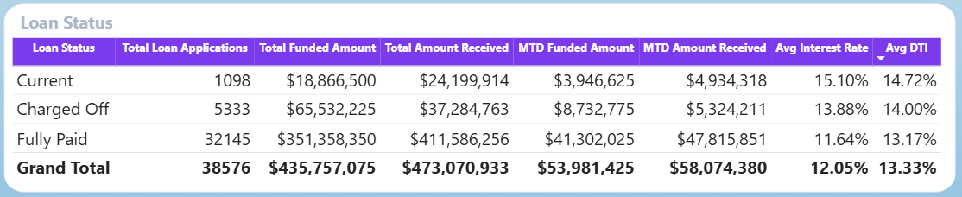
💡 Insight: Helps assess overall loan health and repayment behavior trends.

7. Observations & Recommendations
• Loan growth increased notably during Q4 2021, reflecting higher demand for short-term credit.
• Bad loans account for approximately 14% of total applications, suggesting a need for enhanced risk evaluation.
• The average DTI improved Month-over-Month, indicating stricter borrower screening and improved loan quality.
• Recommendation: Implement stricter underwriting standards and monitor MoM DTI fluctuations for risk mitigation.

8. Case Study Discussion
This case study simulates a real-world data analyst scenario where the goal was to deliver a comprehensive SQL-based loan performance report. The challenges involved creating dynamic date-based KPIs (MTD, PMTD, MoM) and consolidating multiple dimensions (region, purpose, employment) into cohesive visual insights. The analysis improved transparency into lending operations and provided actionable insights for management decisions.

9. Appendix: SQL Reference
• BankLoanReport_Summary.sql – KPI calculation queries
• BankLoanReport_Overview.sql – Visualization and trend queries

